1. Write a program to swap 2 numbers without a temporary variable? Swap 2 strings without a temporary variable? JAVA 18

String –

Is an object and sequence of charactors. i.e every string that you

create is actually an object of type String. String objects are immutable that means once a string object is created it cannot be altered.

There are two ways to create String object:

1.By string literal

String str = "Hello world!";

2.By new keyword

String s1=new String("HelloWorld");

There are several types of String method:

.lenght();

* it returns us the length of the String.

.tolowercase();

->it convert our String to lower case.

.touppercaser();

->it convert our String to upper case.

.intcompareto(String);

.concat(String str);

-> this method append a string to the end of another one.

public class Test {

public static void main(String args[]) {

String s = "Strings are immutable";

s =s.concat("all the time");

System.out.println(s); }

}

.trim();

->This method simply cut the space from the beginning and the end of the sentence of the String.

.charAt();

->This method returns us the location of specific index. String index start from zero.

Public void hello(){

String s= “Today is sunny”;

Syste.out.println(“s.charAt(3)”); -> a

.substring(int beginIndex);

* this method returns us a new string that is a substring of the string.

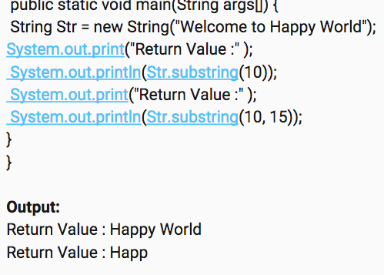

.substring(int beginIndex, int endIndex)

->This method returns a new string that is a substring that begins

with the character at the specified index and extends to the end of

this string.

.replaceall(String regex, String replacement);

* this method replace each substring that matches each regular expression with an specific giving replacement.

A regular expression defines a search pattern for strings.

[A-Z] will look for all character from A-Z in the string

[a-z] will look for all character from a-z in the string

[0-9] will look for all numbers from 0-9 in the string.

.toCharArray();

->this method convert a string to a char array.

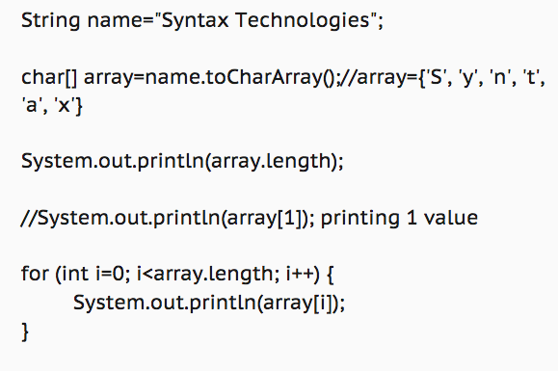

.String[] split(String regex)

->This method splits a string with given regular expression.

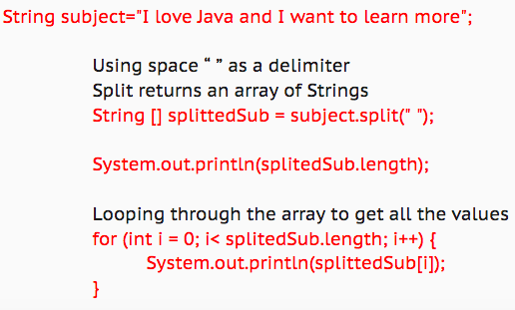

2.Find out how many alpha characters present in a string?

By using .replaceall(); method from String class.

We also using replaceall(regex experession, replacement );

We have 3 types of expression

[A-Z] for capital alphabet

[a-z] for lowercase alphabet

[0-9] for number

^ this means not

3.How to find out the part of the string from a string? What is substring? Find number of words in string?

By using substring

Substring= is a method in string class that gives you part of a string.

By using lenght(); method is string class

To find the number of words in String:

1.to use split method in our String class to break down the sentence to words

2.this method returns me an array of String

3.then we use our Array.length method to find out the number of the words.

4. Write java program to reverse String? Reverse integer? Reverse a string word by word?

we can use Stringbuffer. Or for loop in order to reverse a String

1.create an String object and then use .reverse(); method

**Using for loop**

**1.** we create a null String and then use our decrement for loop.

5. How can you convert a String in to an array? Array to String?  
we have two solution for the second part of the question.

Arrays.toString(char[]); this is a overloading method with the different parameters datatype. That comes from array class

2.String.valueof(object);

this is a overloading method with the different parameters datatype. This comes from String class.

6. Write java program to find second largest number in the array? Maximum and minimum number in the array?

7. How can you remove all duplicates from ArrayList?

8. Versions of java you worked with? What version of java do you currently use in your framework? Difference between JRE, JDK?

9. What are the primitives and wrapper classes?

The primitives are the datatypes. We have 8 primitives such as:

Byte- int- long- short- char- Boolean- double- float.

Using the primitive gives us a value of that primitive. However each primitive has a class known as a wrapper class. In wrapper class we create an object for each primitive.

int a=5; here the variable (a) has a value of 5.

Integer num= new Integer(a); here we have an object with a parameter of value of 5.

10. Difference between == and =.

= is assignmenting a value

== is comparison compiler

11. What is a main method? Why do we need one in java? Do we have to have a main method in java?

Is our java application executor.

12. What is the difference between String and String Buffer? What is mutable and immutable?

StringBuffer is a class in java that is used to make modifications to our string. They are mutable. Changeable.

StringBuffer str= new StringBuffer(String value);

|  |
| --- |
|  |

String StringBuffer

Immutable Mutable

String is slow and consumes Stringbuffer is fast and consume

More memory when we less memory when you contac a

Contact too many Strings String.

Becasuse each time it creates

a new instance.

* Indez starts from 0
* Length starts from1
* For loop works with index

13.How can we access variable without creating an object instance of it? What is Instance variables and how you use it? What is difference between local and instance variable?

14.

Difference between Instance Variable and static Variable? What is static keyword

in java? Where did you use static in your framework?

15.

What is constructor? Use of constructor in class? Can you make the constructor

static? What is difference between constructor and method?

16.

Super vs super()? this vs this()? Can a super() and this() keywords be in same

constructor?

17.

How can you handle exceptions? Types of exceptions you faced in your project?

What is the parent of all exceptions?

18.

How many catch blocks can we have? Which catch block will get executed if u get

ArithmeticException ? Which catch block will get executed if u get LogicalException ?

19.

What is the difference between throw and throws?

20.

What is the difference between final,finally and finalize?

21.

Explain Public Static void main (String args[])?

22.

What is Access Modifiers (Private,public,protected)? How did you use them?

23.

What is the difference between interface and a class? Can we create an object for an

interface? Why do we need Interface in test? Example from your framework?

24.

Difference between abstract class and interface? When to use abstract class and

interface in Java?

25.

Explain OOPS concepts? Is java 100% object oriented?

26.

What is inheritance and benefits of it? Types of inheritance? How do you use it in

your code?

27.

What is polymorphism? Types of polymorphism? How do you use it in your code?

What is static binding vs dynamic/runtime binding?

28.

Method overloading & overriding? How do you use it in your framework? Any

example or practical usage of Run time polymorphism?

2

29.

Can we override/overload main method? Explain the reason? Can you override

static method? Can we overload and overwrite private method?

30.

How does method override differ from abstraction and inheritance?

31.

Can we achieve 100% abstraction in JAVA? Can we achieve 100% abstraction in

JAVA with use of the interfaces?

32.

What is encapsulation?

33.

What is singleton and have used singleton concept in your project ?

34.

What is collection in Java and what type of collections have you used?

35.

What is array and Arraylist (List)? Difference between them?

36.

Difference between ArrayList vs LinkedList?

37.

Difference between HashSet vs HashMap ?

38.

What is Map/ HashMap? How did you use it in your framework?

39.

Difference HashTable vs HashMap ?

40.

What is garbage collector and how to call Garbage Collector?

41.

What is java regular expression?

42.

What is the difference between wait and sleep in java

You have to do overriding when there is an abstraction

You don’t have to override in regular inheritance

When we use abstact inside our class we have to use abstract keyword for undefined method

Encapsulation is basically hiding. Give all the variable from other class which changing access modifier to private.

What is default value of int =0

What is default value of String = null

What is default value of object = null